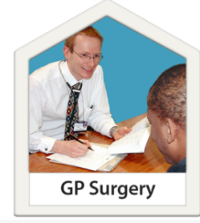
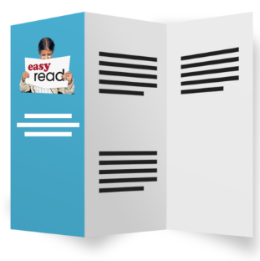
Accessible Information

and your GP practice

Healthwatch Brent has asked Brent Mencap to find out how well GP practices talk and give information to people with:
- Sight Loss
- Hearing problems
- Learning Disability.

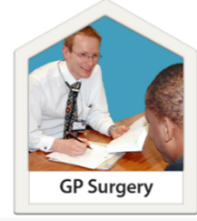 | - Is your GP surgery in Brent?

Yes | No | Don’t  Know

- Do you have problems hearing people when they talk to you?

Do you have hearing aids or are you deaf?

Yes | No | Don’t  Know

- Do you find it difficult to:
- see information
- read information
- Or are you blind?

Yes | No | Don’t  Know

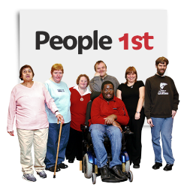 | - Do you have a learning disability?

Yes | No | Don’t  Know

- Do you find it difficult to understand information from your GP staff because you have:
- sight loss
- hearing problems
- a learning disability?

Yes | No | Don’t  Know

6. Has your GP surgery asked you the best ways to give you information and the best ways to communicate with you?

Yes | No | Don’t  Know

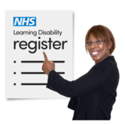 | 7. Does your GP practice tell other NHS services that you have:  - Sight Problems  - Hearing Problems  - Or a Learning Disability?

Yes | No | Don’t  Know

8. Has your GP practice made it easier for you to:
- Understand information
- To communicate with you?

Yes | No | Don’t  Know

9. If yes, please tell us how your GP practice has made it easier to understand or communicate better with you.

For example:
- using large print
- easy read
- text messages
- reminders
- emails
- phone calls
- longer appointments
- or any other ways

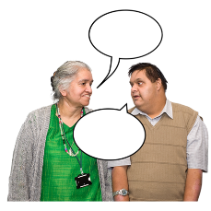

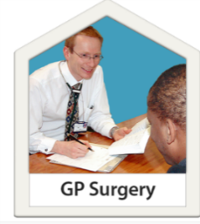  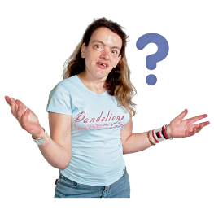 | 10. What else could your GP practice do to communicate with you better because of your needs?

