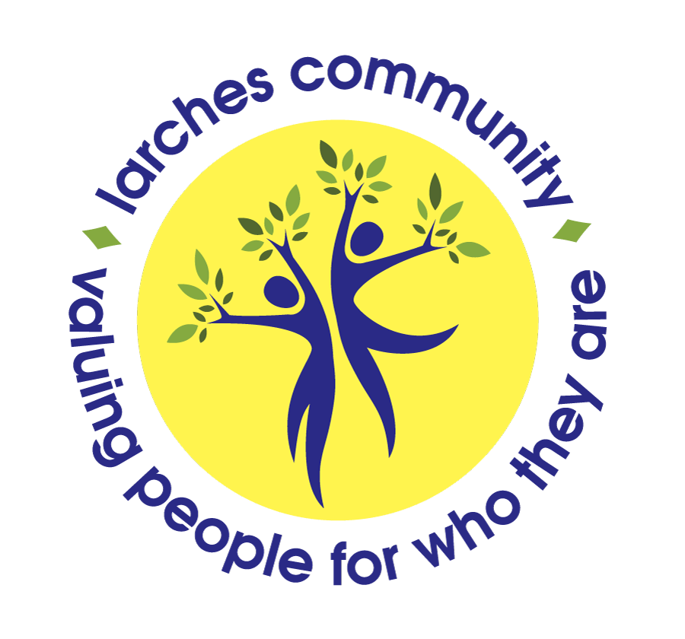

Larches Craft Brewery
Producing exciting and diverse malt drinks, craft beers and ales.

What is the course about?

A 12 week course covering fermentation and brewing
to create top quality beverages for tasting and
graduation events.

What we will cover?

Uses of professional equipment and recipes to create
non-alcoholic malt drinks and craft ales.

Looking at the ethics of alcohol and the joy of non-alcoholic drinks and the science of fermentation, brewing ingredients and processes with actual hands on brewing and bottling experience.

What will I achieve by the end of the course?

The ability to make safe informed choices, build hygiene skills, gain the ability to make high quality fermented drinks in a safe environment and build your hospitality skills for the tasting events.

What is the course and do I need any particular skills?

The ability to follow basic instructions, be safe in an environment similar to a kitchen/cooking activity and using hot liquids and the safe handling of cleaning chemicals.

How will I learn?

Group discussion and tutor lead information about beverage making process and the equipment involved. Group hands on practical work using a professional grain-brewing machine leading up to bottling, labeling and hospitality at the tasting events.

Are there any costs?

£360 for 12-week course

When I’m finished what happens then?
Presentation of the finished beverages at Tasting and Graduation events and see if you would like to further your knowledge and potentially look at formal accredited courses.

To register your interest, please complete and return the form below:
Larches House,1 Rectory Lane, Edgware, Middlesex HA8 7LF

Please complete and return to the above address or return to: Rumela.Kundu@larchestrust.org.uk

Name:
Address:
Post Code:
Contact No:
E-mail

