+

What we are doing:

Saturday 4th May 2018 to Saturday 13th July 2019
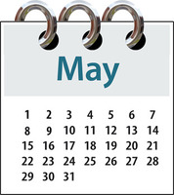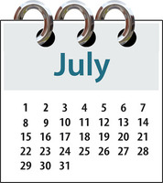

Dear Bonanza Club member,

The next Bonanza payment is due before 4th May 2019
Please pay £48.00 if you would like to attend all of the sessions

Each session cost £8

If you made a payment and cannot attend, you will not get refund.

Fees can be paid in cash or by cheque, made payable to:
Brent Mencap Ltd at the Brent Mencap Office 379-381 High Road, Willesden, NW10 2JR (Monday to Friday between 9.30am-4pm) (please call before you come to ensure staff are available)

If you have any questions regarding Bonanza Club please call Brent Mencap on 0208 451 5278 or email the Administrator administrator@brentmencap.org.uk

Date and Time | Activity | Estimated Cost (£) |  | What do I need to bring?
Saturday  4th May 2019  12pm to 3pm | Queens Park | Money if you buy lunch in the Park Café or  Packed lunch | 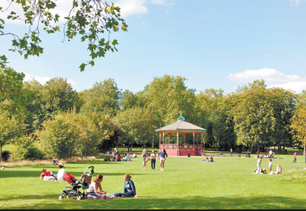 | Your Freedom Pass  to travel on the Bus
Saturday  18th May 2019  12pm to 3pm | Onsite Games including  Mega picture BINGO!! | £0.00 |  | A sharp eye and loud voice
Saturday  1st June 2019  12pm to 3pm | Canal Walk | Money if you would like to buy lunch in the Café or Packed lunch | 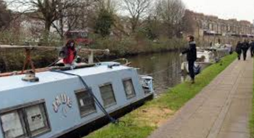 | Freedom pass to travel on the Bus
Saturday  15th June 2019  12pm to 3pm | Karaoke! | £0.00 |  | Bring your singing voice!
Saturday  29th June 2019  12pm to 3pm | Onsite Games  Indoor Bowling | £0.00
Saturday  13th July 2019  12pm to 3pm | Chinese Meal at  New Golden Duck | £9.00  For meal and drink |  | An empty belly
What we are doing

